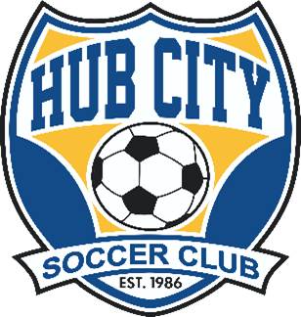
Hub City Soccer Club Fall Competitive Soccer

- All Hub City Soccer Club players U8 (birth year 2015) through U12 (birth year 2011) will be eligible to participate this Fall (note that U13/2010 birth year and older players are also included but will be called HCSC Eagles).
- Participation in the HCSC Fall Competitive program gives the player training with HCSC Coaches, eligibility to travel to competitive Fall events throughout the region, and the ability to get regular matches through the HCSC City Recreational League.
- Training will begin as soon as teams/age groups are formed (and registered). Trainings will be held approximately once per week (possibly moving to two times per week later in the season). Training days/times games will be scheduled around weekly games and any travel events the team may participate in. PLEASE NOTE: The Fall schedule is incredibly busy for players/coaches/everybody with Fall High School soccer, school, and other activities. Fall competitive teams will NOT train as often as they do in the Spring/Summer, and the program cost reflects this.
- HCSC teams/players will be able to travel to various Fall events based upon availability. Event registration will follow the same procedure used for Spring/Summer/Winter events, and the costs for events will be figured using the same formula that is used during the Spring/Summer/Winter. Traveling to events is optional, and a player may choose to go to as many, or as few events as they desire.
- All other policies and procedures related to the Fall Competitive program will follow standard club policies (uniforms, playing up, financial assistance, guest playing, etc). If you have questions about any of these items, please ask.
- The registration fee is $109 per player. Please note - this registration fee INCLUDES registration in the Fall HCSC Youth League, and player will be placed on a youth league/recreational league team at no additional cost. So, the actual additional cost to participate in the Fall competitive program is $35 ($74 for Fall Youth League Registration + $35 for Fall Competitive = $109). If you have already registered and paid for the Fall Youth League, that is no problem, your Fall competitive registration fee will be adjusted accordingly.
- What else is included in this registration fee? SDYS (South Dakota Youth Soccer), USYS (United States Youth Soccer), and US Club (United States Club Soccer) Registration fees, secondary insurance for players, coaches cost for training, training equipment, and any training facility costs and maintenance. The “TeamSnap” mobile scheduling app that will be used for all competitive team training and event management.

- What is new this Fall? HCSC has been asked, and has accepted, an invitation to join a second national soccer organization (US Club Soccer). Because of this new affiliation, all HCSC competitive players will be registered with both US Youth Soccer, and US Club Soccer, which will give players increased playing opportunities.
- Registration can be completed using the following link: https://go.teamsnap.com/forms/328736
If you have questions about anything, please contact the Hub City Soccer office at 225-0088 or aberdeensoccer@nvc.net

